# Importing Build Pipeline in Devops :

Need to copy below json file in local folder location and select it while importing .



1. Need to Sign into your Azure DevOps organization and navigate to your project.
2. In your project, navigate to the **Pipelines** page.
3. Click on **+New** button, then choose the import a pipeline action to create a new pipeline.

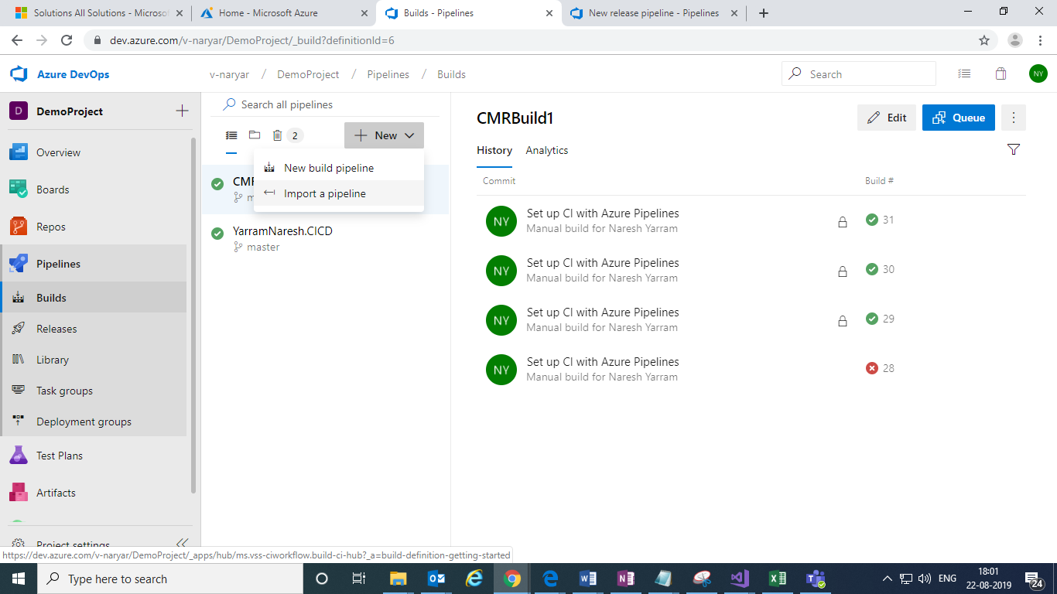

1. It will prompt to browse the existing build pipeline json file , select valid build pipeline json file click in import button.

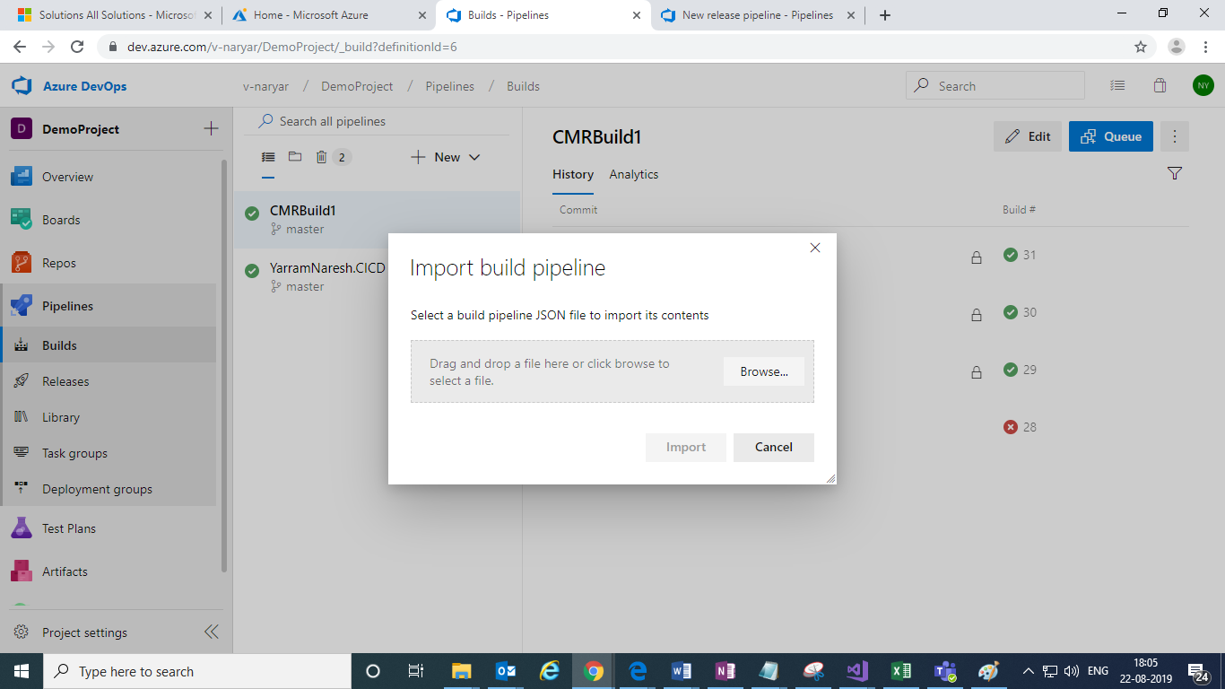

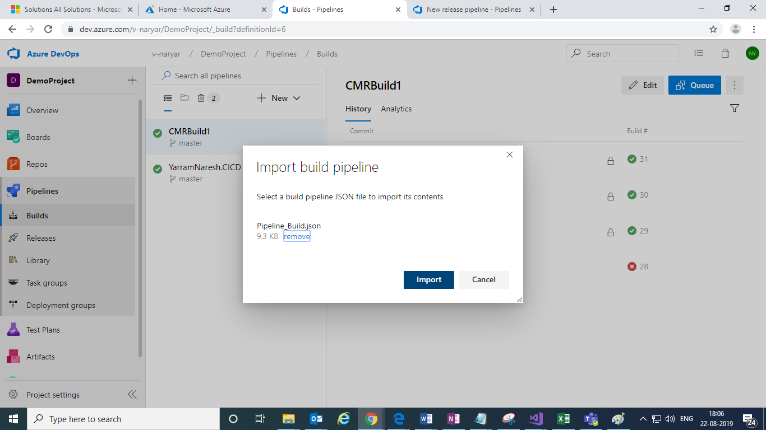

1. After imported it below screen appears and here we need to select the **Agent Pool** value .

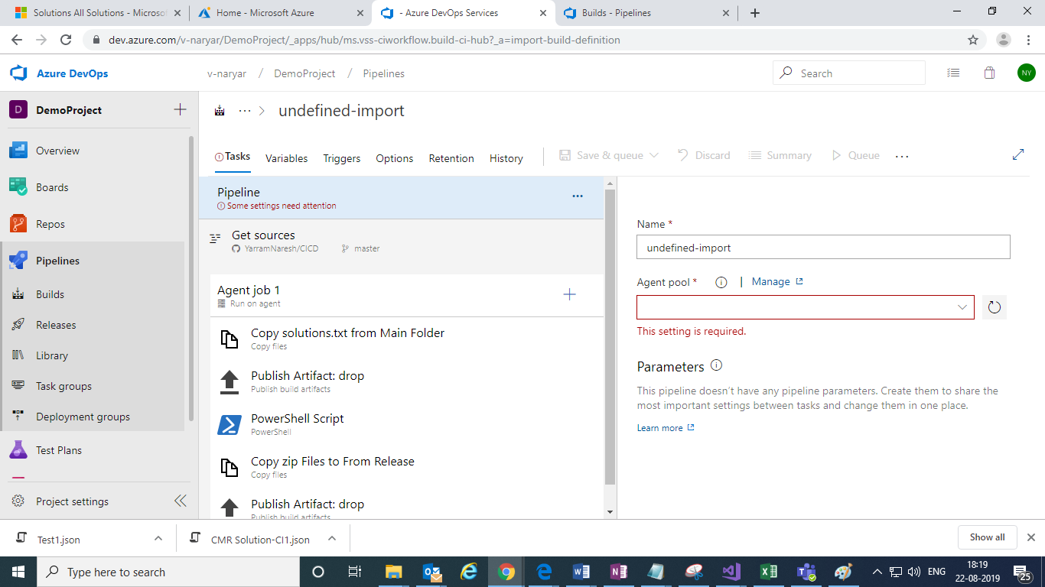

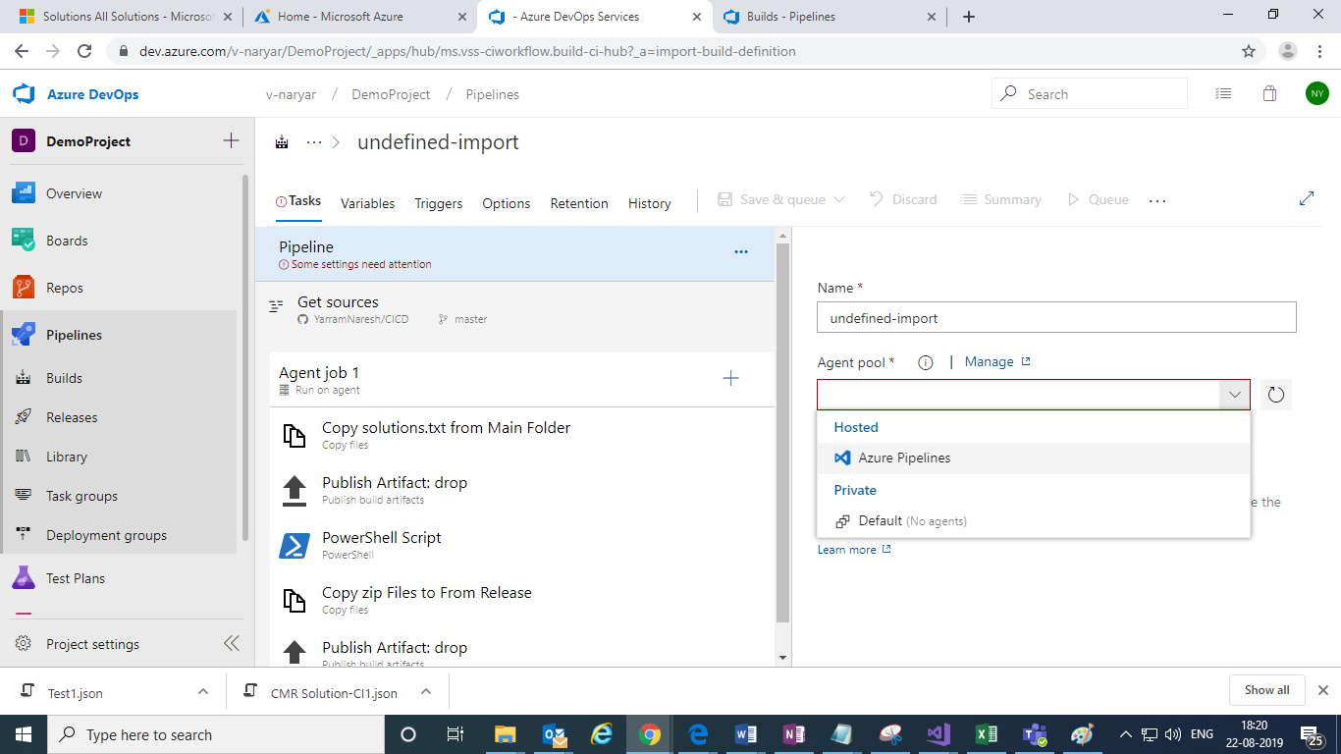

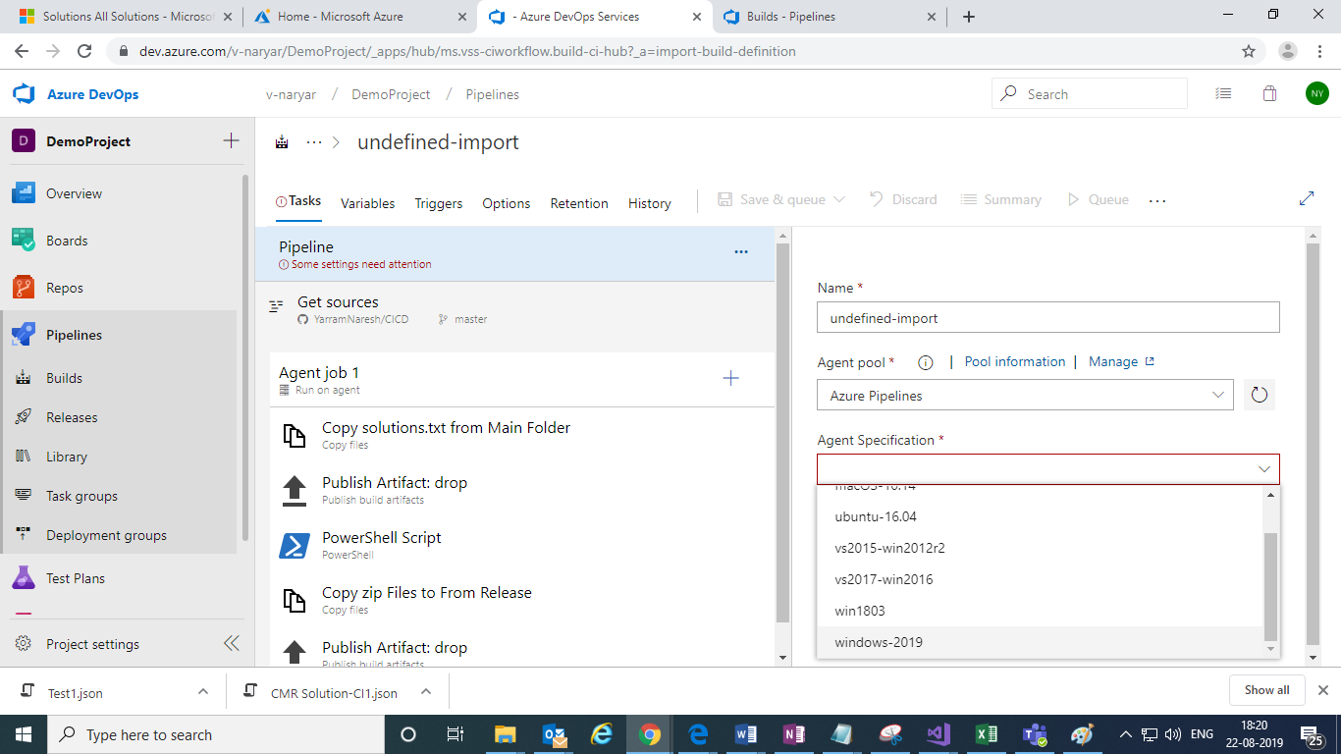

And select agent specification .

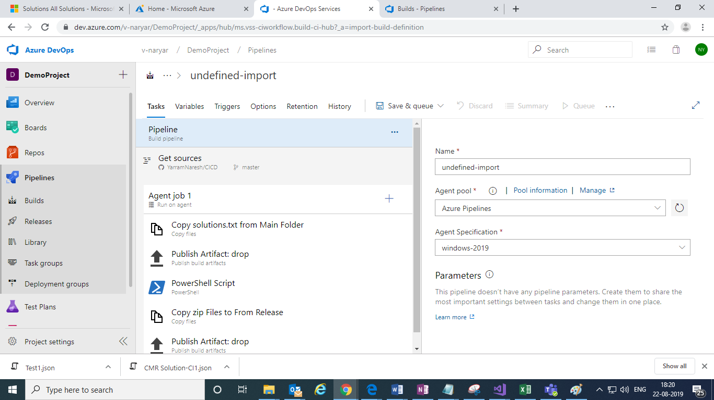

And rename the build pipeline as required:

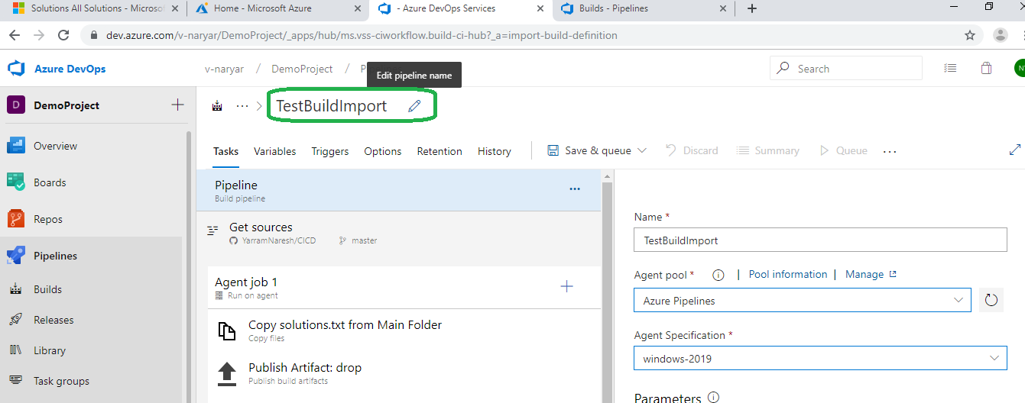

1. Now click on Get Sources section to select preferred source control.

And here for example we are connecting to git source control:

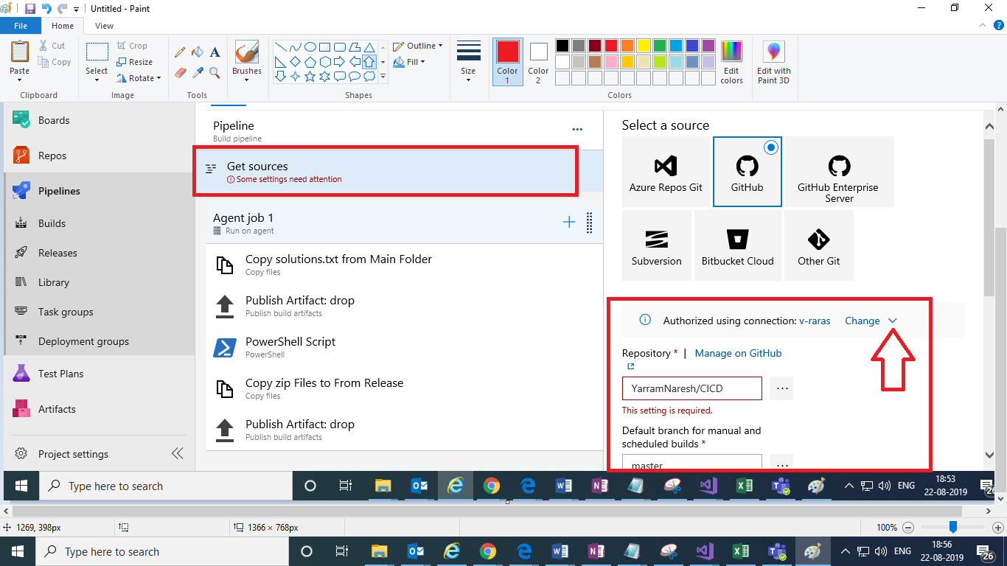

Click on **change** link to change the connection ,

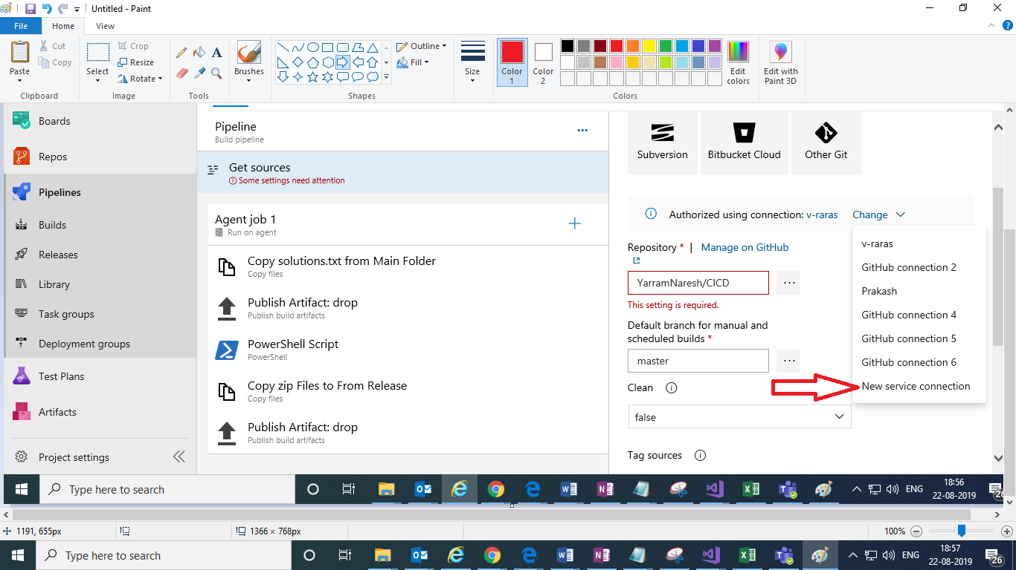

and New service connection in above screen:

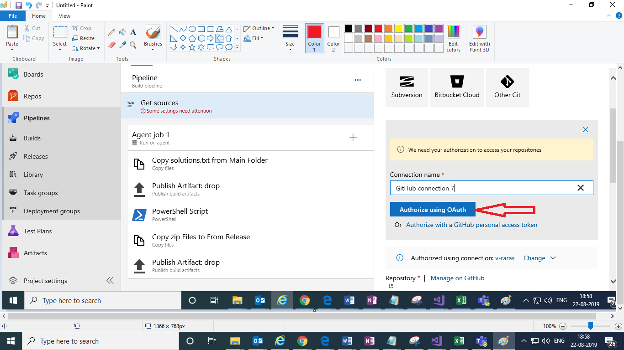

Click on **Authorize using OAuth** button in above screen,

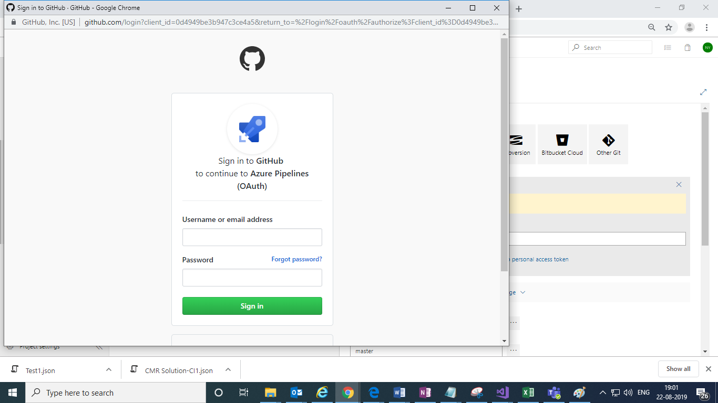

Here we need to login to GitHub in below screen,After Login, click on **…** in below screen to select the valid git repository

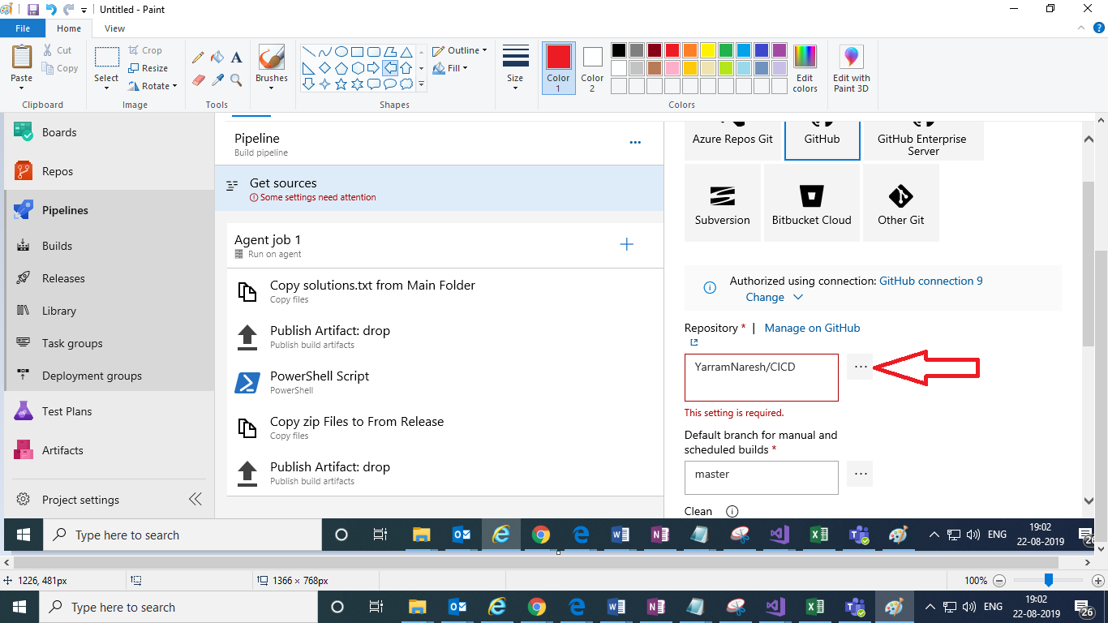

Select appropriate repository from below screen,

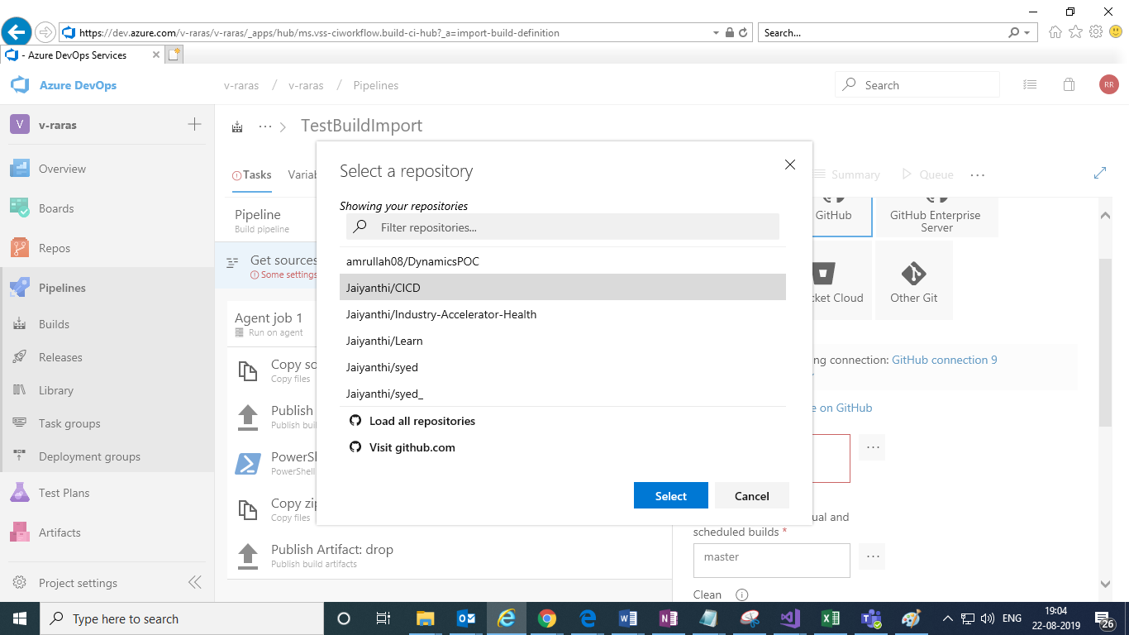

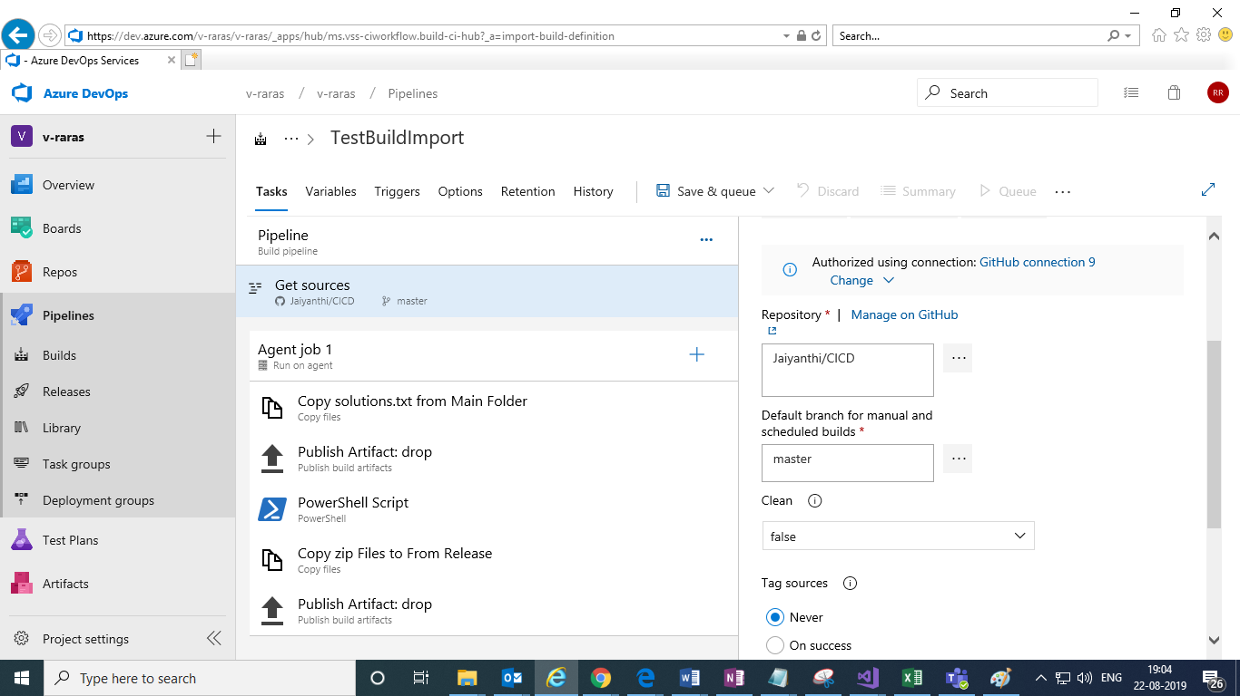

1. Click on Save to save as shown in below screen,

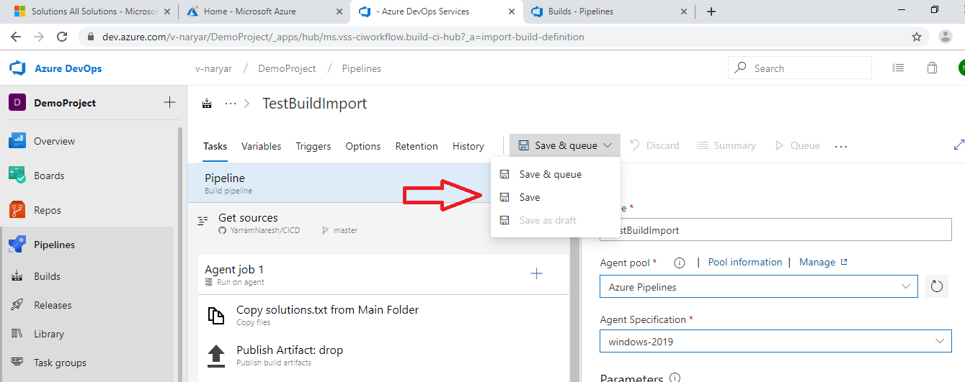

Click on Save in below screen,

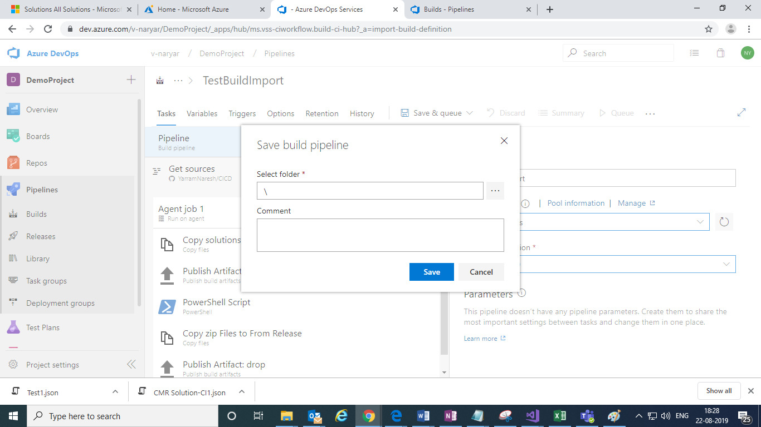

1. After Saving click on Queue button in below screen to run the build:

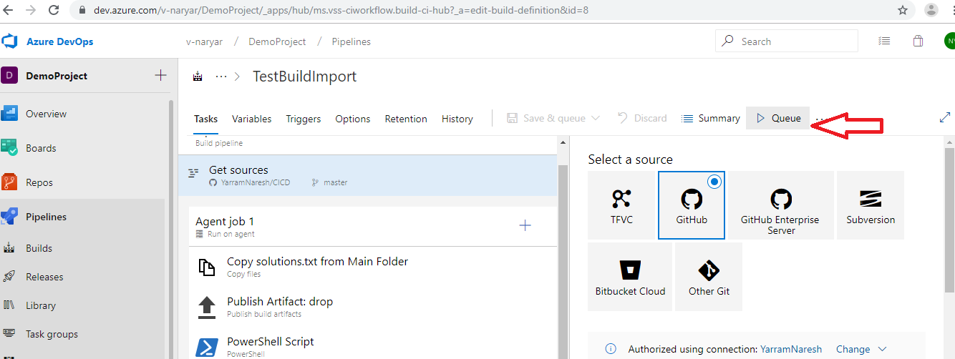

Click on Run in below screen,

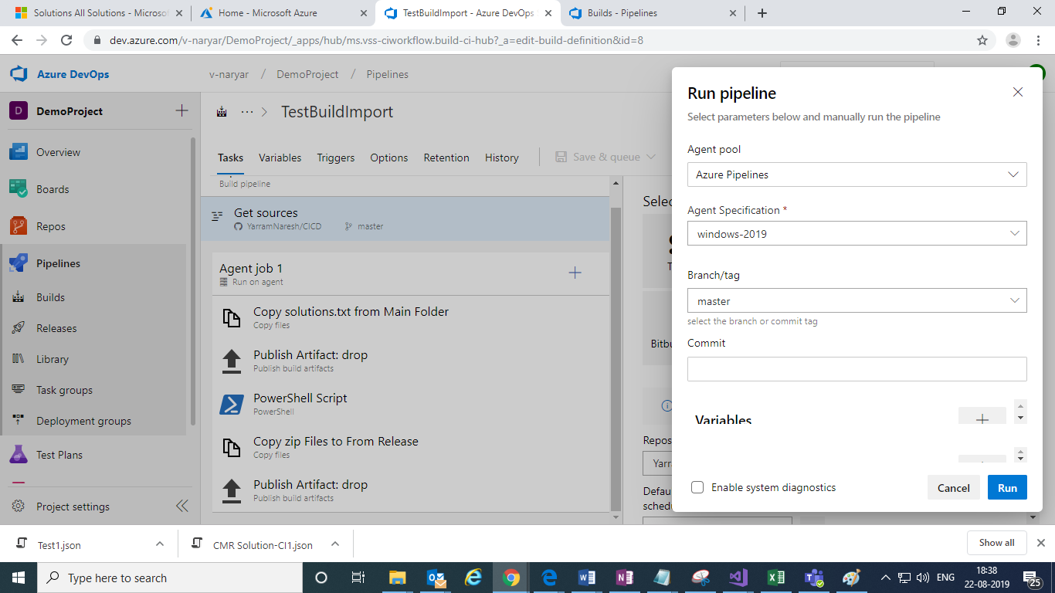

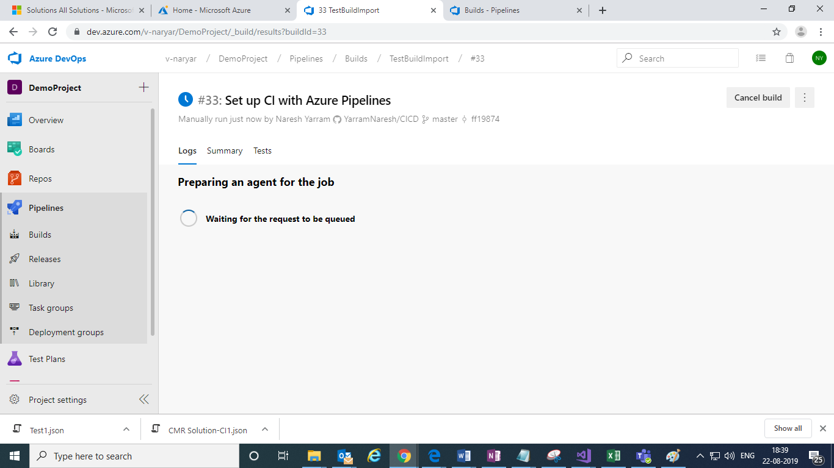

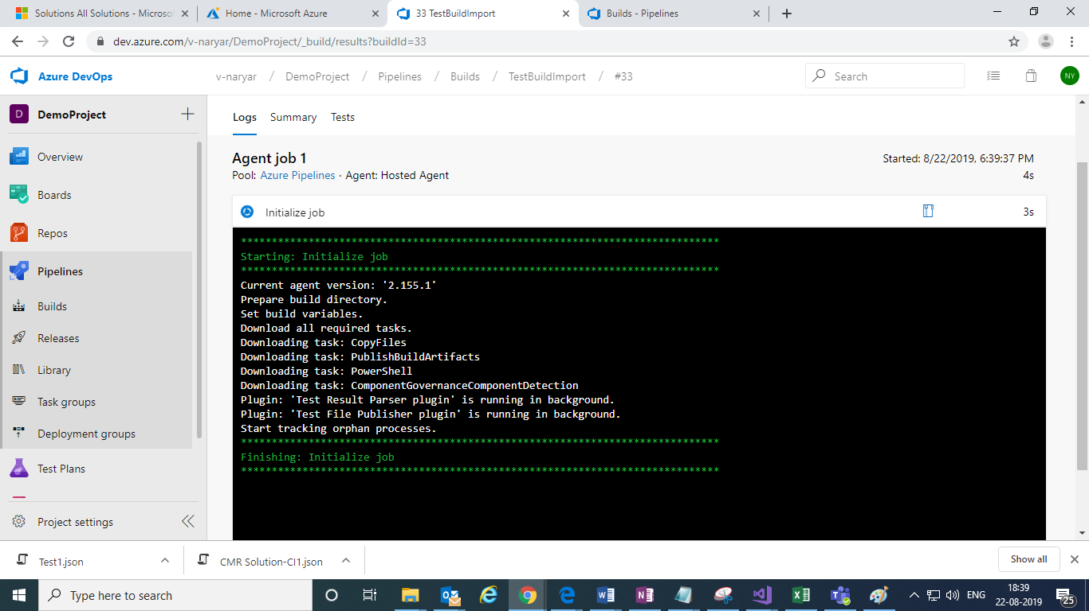

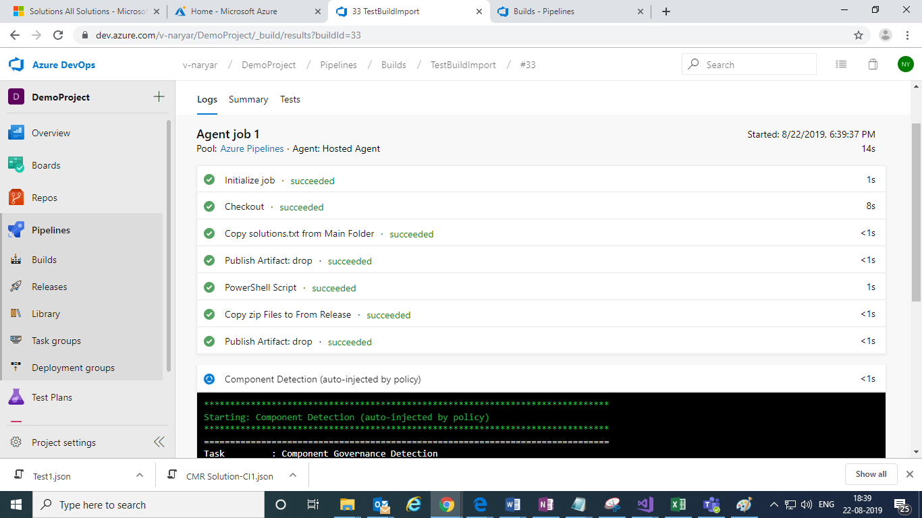

Build run successfully.

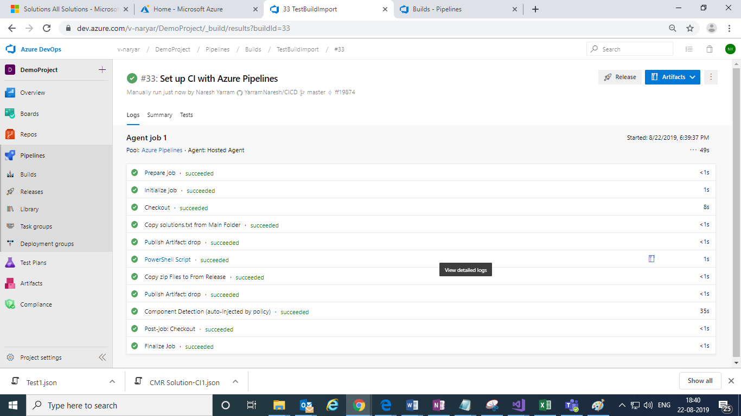

Click on build and it will show all build pipelines:

